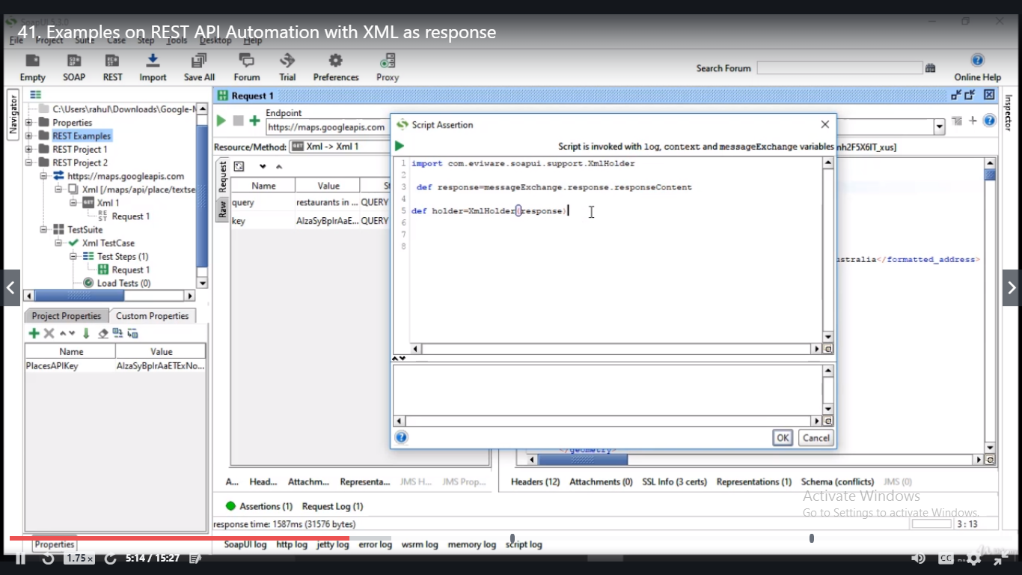

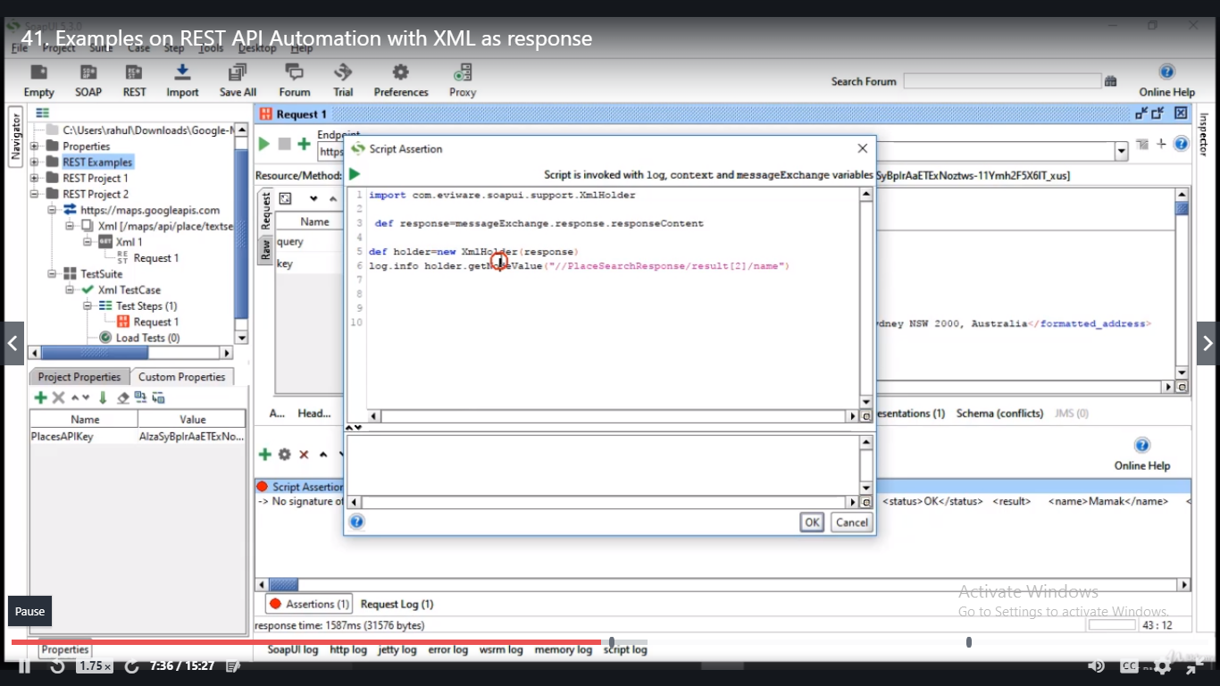

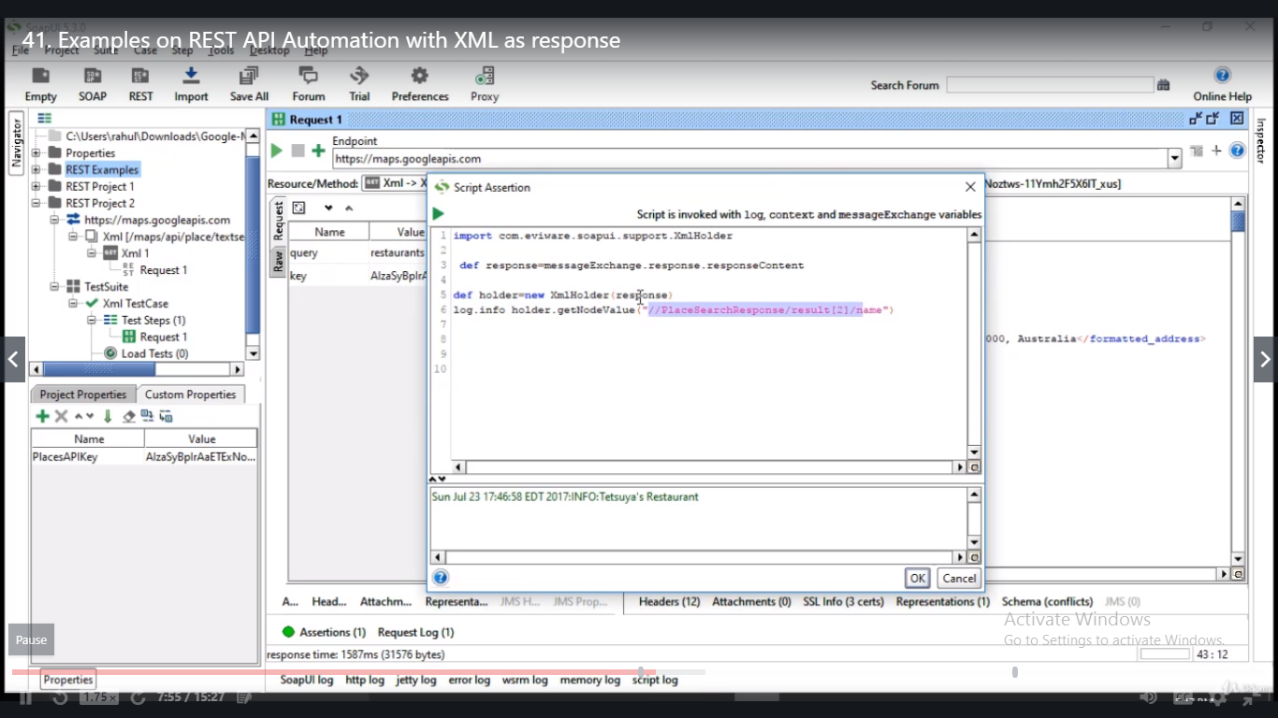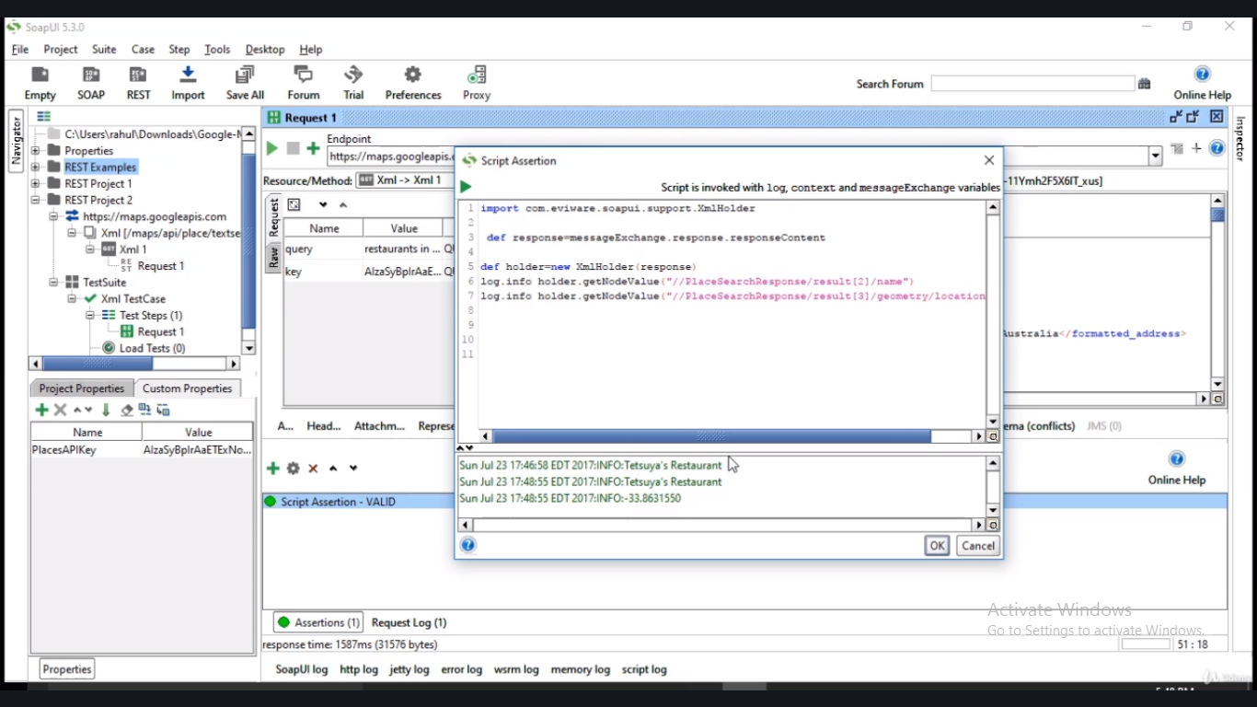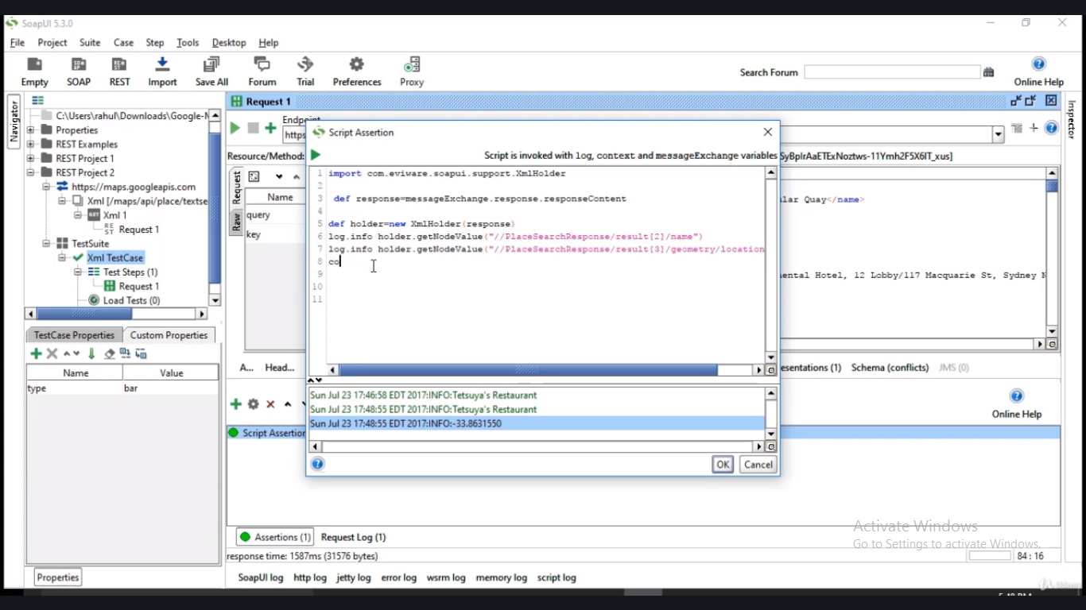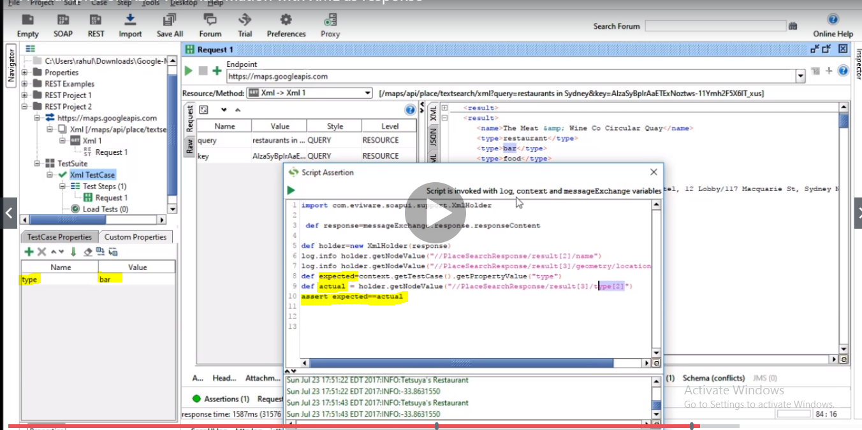

* Pros and cons of Script Assertion.

In groovy you have more flexibility like you can update your xml back in request.

But in Script Assertion you can only validate your responses. If you want to run your test cases like wsdltest.run or if you want to update your json with new values, all these complicated scenarios can be happened through groovy test.